Standards and Best Practices for eBusiness Wireframes
This document is to provide recommendations, standards, and best practices to help us ensure we are being consistent across all eBusiness projects. Please review carefully as this will allow TMA to be more productive, consistent, and efficient when creating wireframes for product development and projects in Professional Services.

General Guidelines to consider in Wireframe Creation
Here are the guidelines that are listed in all Marketing Requirements Documents (MRD) to follow as part of our process.
- The controls and forms that are designed through this process need to be 508 compliant. The standard of design to support this will be defined separately.
- The controls and forms that are designed through this process must render on a mobile device, and render gracefully on a tablet (specific versions TBD).
- All controls and forms must support skinning through standard CSS practices; fonts, colors, spacing, etc., cannot be hardcoded except where absolutely necessary.
- The system should leverage configurable options in Personify where practical, such as system types and codes, and field caption labels, to reduce the need for customers to customize where possible.
- Error messages need to be clear and grammatically correct. Where business logic is not being met, the customers should be able to customize these messages. In the absence of a comprehensive, indexed list of error messages, any error messages identified during the Technical Design and QA phases of a project need to be reviewed with the Design team, who will offer the appropriate text and potentially a default value.
- All financial transactions must support multi-currency.
- The system should support the ‘reset this form’ functionality. This may not be appropriate for all forms but Designers should consider if this is necessary on a case by case basis.
- All data entry fields should be available via the appropriate universes for reporting purposes. Even existing fields that are used in a design need to be validated to ensure they are in an appropriate universe(s).
- All records created or edited by these transactions should be linked to that customer’s login for purpose of auditing information (e.g., created by JMember on 5/23/2010, not ‘webuser’, ‘sysadmin’ or other generic accounts).
- In any case where an address is added or entered and the organization uses an address verification, such as PBBI, the user must be allowed to proceed with entering an address that the validation system believes is bad. The customer must be allowed to advance through the process with the address they believe to be correct.
- In all cases, these user stories are assuming a streamlined process and are limiting the number of extraneous options that can be added (e.g. at checkout, if an order does not require shipping, do not ask for a shipping address; if a transaction does not require payment, do not require users to enter a credit card).
- Email addresses entered should be validated to ensure they conform to the standard format, but otherwise will not be validated to ensure they are legitimate addresses (e.g., mailbox exists).
- Our general assumption is that we are not implementing any support for multi-lingual pages nor the ability to localize pages.
- Where possible, the controls should leverage entity-based web services - not service operations. A majority of customers will wish to customize these controls using Web Services Designer.
- The following philosophy needs to be adhered to, and if this is not possible, then Product Marketing and DES teams need to be alerted:
  - Build a number of simple controls that will do a very specific thing simply (If we can envision distinct variations, we would ultimately build different controls for each)
  - These controls leverage Entity-based Web Services built with the Web Services Designer
  - Options will not be configured in the controls, unless explicitly requested (If customers want to change the controls, they would do so via code, and not configuration built into the controls)
- URLs should never be hard-coded, as they will be different for every client. Configuration WILL need to be configurable by each client.
- URLs should never be literal (http:); instead, they should be relative

Base Widget Library Info
Name | Standard | Example
Base.rplib | Select “Load Library” from the widgets panel in axure to load file which will be saved in “My Axure RP Libraries” folder | 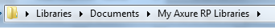
Saved Location | To get the latest version, go to:

Accessibility Considerations
Name | Standard | Example
Text Links (context) | Use meaningful words for all text links and refrain from using “click here“ | Register for this event to….  Update your profile…..  Sign in to gain access….
Forms | Every form element needs to have an associated text label. The label must be unique from all other form elements in that group.
Tables | Form labels cannot be in a column header – DO NOT USE | 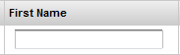

Base Wireframe Considerations (2 examples, but may have more in the prototype)
Name | Page | Example
Demonstration of Flows | On the Addresses page, when you click on the “Add Address” link, it will show 3 different paths that can be taken. This is to demonstrate the possible path and is not meant to be developed this way. It is a flow in the wireframe. | 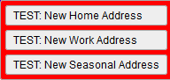
Demonstration of Flows | On the “My Profile” and “Biography” page, when you click on the “Save” button in the modal for the Add/Edit Photo, it shows 2 different paths based on what was selected. This is to demonstrate the possible path and is not meant to be developed this way. It is a flow in the wireframe. | 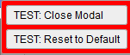
Convention Standards (Text)
Name | Standard (as noted in base widgets) | Example
Font | Arial  16 points, #333333, bold for page title text <h1>  14 points, #333333, bold for subheading text <h2>  12 points, #333333 bold for regular text <body>  12 points, #000000 regular text <body> | Page Title  Page Header  Subheader  Body Text
Date Format | Use numbers for all dates and date ranges in tables. Do not use leading zeros. Use 4 digits for the year.  Dates should be right aligned in cells  For meetings, spell out the day of the week if it is displaying in the Agenda or Schedule, and use the abbreviation for the month in shortened format.  For product listing with sale prices, should spell out the month/day | Month/Day/Year  10/12/2012  1/12/2013  Meeting:  Wednesday, Oct 12, 2012  Now on sale through Oct 21, 2012
Title Case | The first letter of each word is capitalized. The following words should NOT be capitalized:
  - a  - an  - and  - are | - as  - at  - but  - for | - from  - if  - in  - into | - of  - over  - or  - per | - that  - the  - to  - versus | - with  - without
Time Format | Use all uppercase for AM and PM.  - Do not use periods  - There should be a space between the last number and the letter “A” or “P”  - Use a – in between ranges  - Do not use leading zeros  - Show Time zone for all Events | 8:00 AM – 12:00 PM EST
Phone Number Format | Should use () for area code, next three digits, dash, then final digits for US numbers  - Should use separate boxes based on format of country  - United States format is default to display | (view mode)  (703) 491-6419 Ext. 1234  (edit mode)  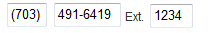  (Blank)  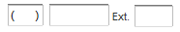
Currency | Use the “$” for accounts that only use American dollars.  - There should be no space between the “$” and the number.  - Show $ and USD for American accounts  - All currency (numbers) should be right aligned when displayed in a table cell.  - Show in dollars and cents.  - Use commas for numbers over 3 digits.  Use USD for accounts that use multiple currencies, with the “$” | $49.00 USD  $678.99 USD  $1,250.00 USD  $49.00 USD  $678.99 USD  $1,250.00 USD
Numbers in table cells or list format | All numbers should be right aligned – this applies to:  - Quantity  - Currency  - Dates (if in number format)  - Use commas for numbers over 3 digits | 500  45  1,575
Notes on form elements | For Notes: Arial 11 pts, italic text displayed under textboxt, right align preferred  For Links: Arial 11pts, blue underline links displayed to the right of textbox  - Do not bold  - Vertically centered from textbox  - For link “Why can’t I change this?” on hover the light yellow box should appear with additional information. |   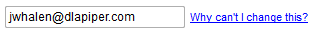
State/Country dropdowns | Should be spelled out and not abbreviated

Name | Standard |  | Example
Text Links (format) | Use Title Case for all words when used as an action  - Use blue #0000FF  - Text should be underlined |  | Add Another Row  Register Now  Update Membership Info
Text Labels | Use Title case  - Should be left aligned  - Should not be bold text  - Required fields should have red asterisk with a space between the asterisk and first letter  - Text should not align with the asterisk but the first letter  - Should end with a colon |  | 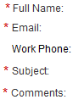
Required Fields | If required fields are present on a page, we need to show “*Required” on the top right of the first form field.  - Required fields should have red asterisk with a space between the asterisk and first letter
Underlines | Only underline text for clickable links. |  | Forward to a Friend
Email | The E should be capitalized.  - The m should be lower case.  - Do not use a dash between “E” and “m”  - Use “Email” vs. “Email Address” |  | Email:
Mobile | Use “Mobile” vs. “Cell” phone
# | Do not use unless there is not enough space for the word “number”
Error Messages  (modals) | Use red #CC0000  - Do not use bullets or italicize text  - Should be in a sentence  - Should display at the top of the form/page with a light yellow background (#FFFF99)  - Highlight textbox/field where area has occurred for easy visibility (error text shown not final)
Error Messages  (modals) | 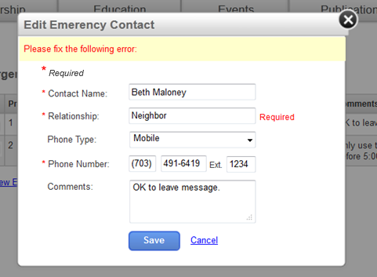
Error Messages (pages) | Use red #CC0000  - Do not use bullets or italicize text  - Should be in a sentence  - Should display at the top of the page underneath the page title with a light yellow background (#FFFF99)  - Highlight textbox/field where area has occurred for easy visibility (error text shown not final)
Example 1 | 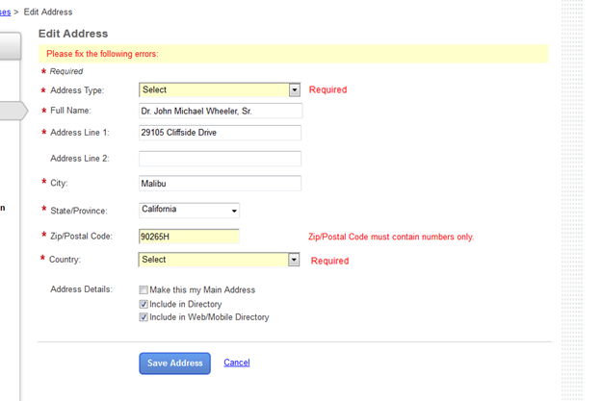
Example 2 | 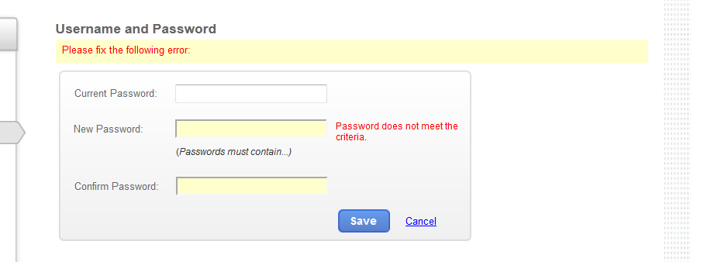
Confirmation Message | - Message that appears that requires the user to select an option to move forward  - Use modal window as message | 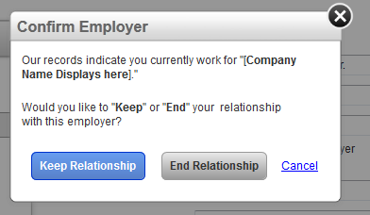
Help IDs/More information on hover | - Icon next to elements - hover over image to see yellow message appear  - Click on “x” to close  - Light yellow background color #FFFFCC | 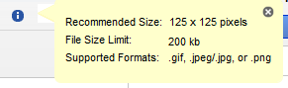

Convention Standards (Elements)
Name | Standard | Example
Action button | Use Blue button for main actions on page  Use Grey button for secondary actions from the “Base Widgets” library | 
Buttons | When displaying buttons in a row on regular pages, the action button should be on the left, and cancel on the right, and the buttons should be let aligned on the page underneath the form fields. Use text links for “Cancel”  When displaying buttons in wizard pages, the action buttons should be left aligned on the page in this order (Previous, Next, Cancel)  When displaying buttons in modal windows, the action button should be on the left and cancel on the right, and the buttons should be left aligned with the form elements on the page.  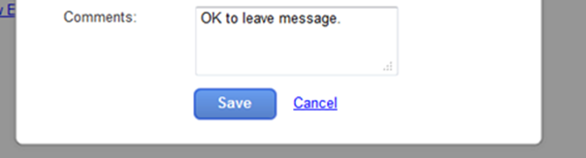 | Left aligned on page  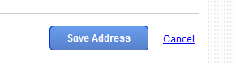  Left aligned on page  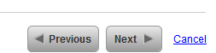
Modals | All modals should have an “x” button in the top right corner to close the window. The heading area should have a grey background, and the background of the page behind the modal should be “greyed out”  - If there is a form in the modal, have action buttons and a “Cancel” link | 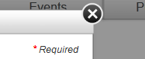
Table Grids | - All column headings should be bold and left aligned  - All column headings should be bottom aligned  - All data should be left aligned with the exception of numbers for currency, quantity, and amounts.  - First row should be white #FFFFFF  - Alt row should be grey #F2F2F2F2  - Indicate sorted column with a triangle | 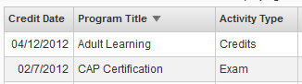
 | 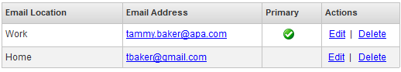
Date Picker  (Telerik Control) | As of now, development is using a calendar control from TELERIK, but this may change  Use a textbox and calendar icon so users can pick a date from the calendar.  - Use in events for selecting dates within the current year, or 2011, 2013.  - Clicking on the icon should display a monthly view of the calendar for the user to select the date | 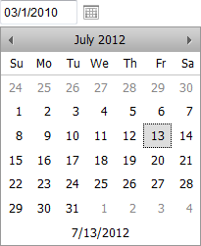
Time Picker  (Telerik Control) | Use a textbox and clock icon so users can pick a time from the dropdown.  - Do not use individual dropdowns for hour/am/pm |   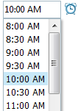
Left Nav – page indicator | Use arrow with grey background to indicate the page the user is currently on. The name of the page should be in bold text. | 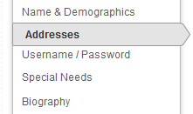
Checkmark indicator (view mode) | Use a grey checkmark to indicate which items have been selected in view mode | 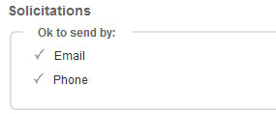
Checkmark indicator or groups of checkboxes (edit mode) | For quick select all and select none, a main checkbox should appear with the category  - When checkbox for “Health and Fitness” is checked, all boxes underneath should check.  - When checkbox for “Health and Fitness” is unchecked, all boxes underneath should uncheck. | 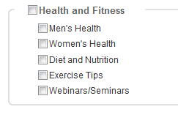

Name | Standard | Example
Wizards | - Buttons are Previous, Next, and Cancel with are left aligned on the bottom of the page  - Wizard should span entire page and does not include the left navigation, main navigation, or main header with links and social media icons  - Use special header used for wizards (Logo and line, then wizard navigation)  - For navigation bar, all steps have Step X and name of step. Step you are on is in bold font - steps that are off are in grey text  - You can go back to a previous step by clicking on the link text, but you cannot move forward  - The steps that have already been done should show as clickable, the steps that have not been clicked on should not look clickable  - Use double arrows in between each step  - There may be a few steps within a step, so steps may not change on each page – will vary by settings, user, and accounts  - For Step 1, only show “Next” and Cancel – not previous.  - For last step, don not say “Next” but “Finish” or something similar to let user know is at end of step | 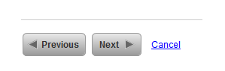
Modules/Controls | Sections of content should be displayed in rounded corner boxes when possible  - Content area should have gradient from light grey to darker grey as shown to the right | 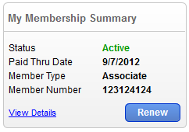
Expand/Collapse | Use of Arrows  - When expanded, arrow should be pointing down  - When collapsed, arrow should be pointing to the right  Use of +/-  - When expanded, minus sign should display  - When collapsed, plus sign should display | Yes, for main headings  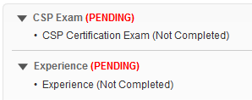  Yes, for listings in web grids to expand and show the description
  View Closed  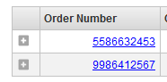 | View Expanded  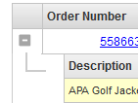
Cart | In checkout, use bullets to list individual items or sessions as part of that purchase/package. Do NOT use bullets for attributes such as color, size, etc. | 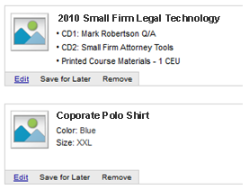
Marketing Control Messages | You might also like:  Not title case | 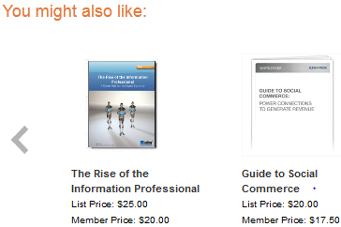
Displaying Credits in Main Image | If a product offers CLE credit, a ribbon with the amount of credit should display over the image on the product detail, cart, and order confirmation pages. | 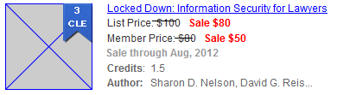

Layout of Main Elements (960 pixels)
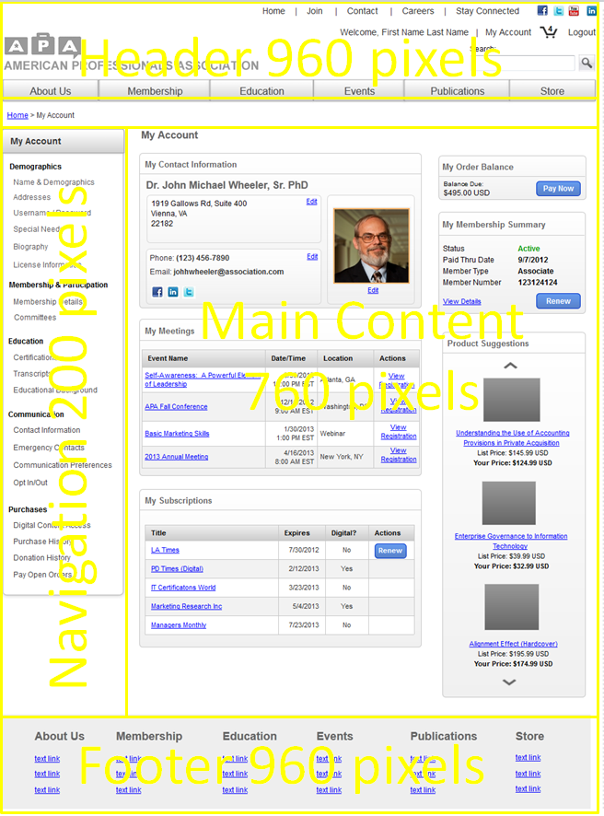
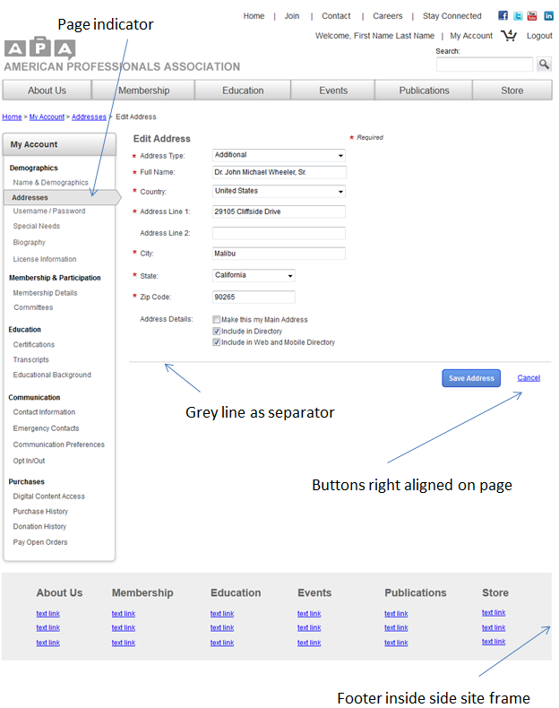
Wizard Pages
